2026 Codex Beginner Guide: Installation, Usage, and Automation Best Practices
Codex, as a new-generation AI programming and automation tool, offers clear advantages over traditional tools like Claude Code. It avoids issues such as account bans, degraded performance, and rate limits, while significantly improving task execution, usage capacity, and multi-task handling. Especially in automation and project management, Codex is quickly becoming a go-to tool for developers and AI workflow users.
This guide walks through Codex installation, core features, and real-world applications, explaining what it can do and how beginners can get started.

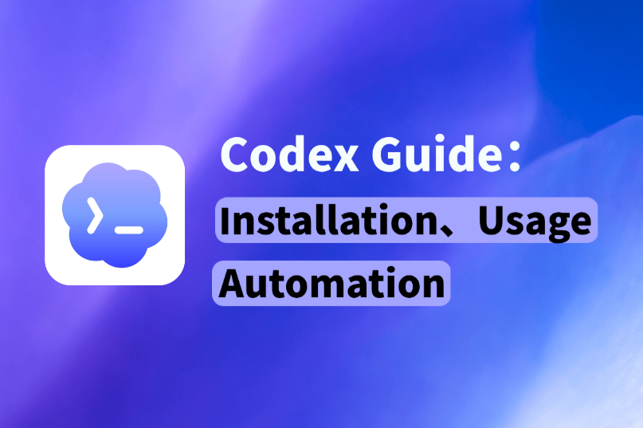

I. What is Codex?
Codex is a powerful programming assistant developed by OpenAI. It supports natural language programming, code generation, debugging, and project understanding via desktop app (App), CLI, or VS Code extension.
The Codex App is one of the core “execution-layer” products in the Codex ecosystem. Its functionality is already quite mature, especially in automation and task execution. Unlike earlier tools that focused mainly on model capabilities, Codex App functions more like an “executable AI workspace,” allowing users to directly complete development, automation, and task management workflows. It is essentially the closest form to a real production environment.
From practical usage, Codex capabilities mainly focus on:
- Development assistance (code generation, debugging, refactoring)
- Automation execution (batch processing, script execution)
- Multi-task management (running multiple projects simultaneously)
- External system integration (API calls, data processing)
The interface structure of Codex is clear and consists of three main parts:
- Project panel: used to create and manage tasks, supports running multiple projects simultaneously
- Chat panel: used to interact with AI, input requirements, adjust logic, and refine execution
- Navigation panel: includes permissions, tool usage, and execution logs
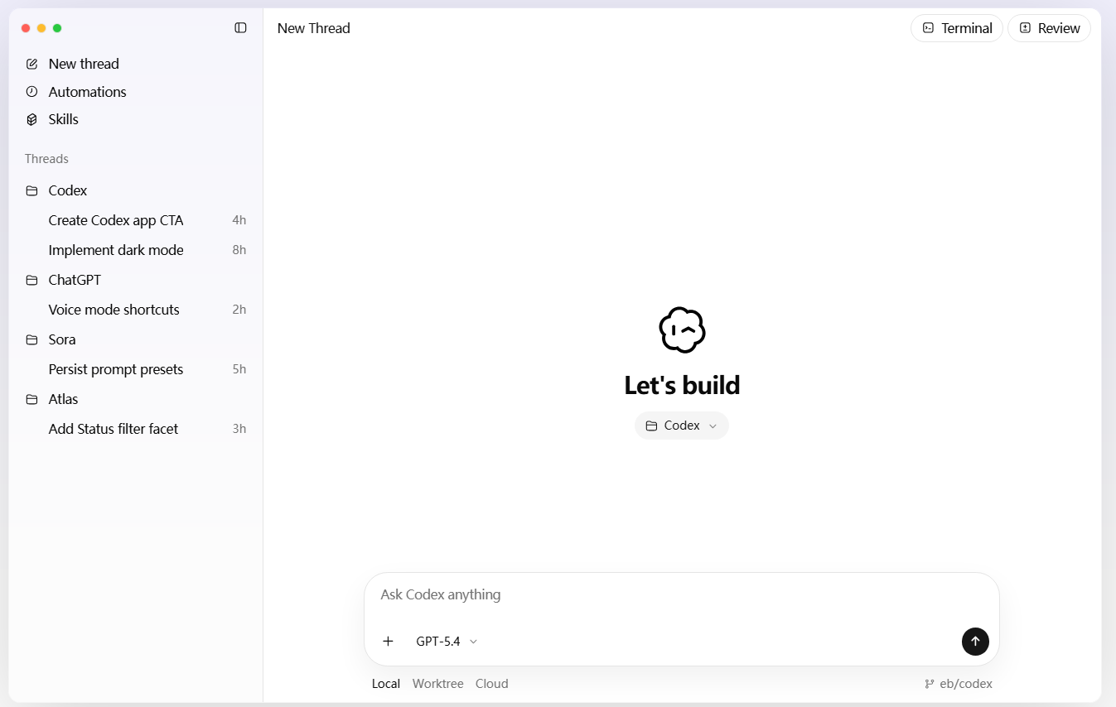

II. Codex Installation and Login Guide (2026)

Installation prerequisites
Before installing Codex, ensure the following conditions are met:
- A registered ChatGPT account
- Supported operating system (Windows / macOS)
- A stable network environment to access OpenAI services
If the network is unstable, login verification or loading errors may occur during setup.

Installation steps
Step 1: Download and install the Codex App
Download the installation package from the official website, select the correct system version, and follow the installation prompts.
Step 2: Log in with your ChatGPT account
Codex App relies on the OpenAI account system. After logging in, permissions and usage limits will sync automatically.
On first launch, Codex will usually prompt you to select a working directory.
Once completed, the Codex App is ready to use.

Troubleshooting installation or login issues
Common issues during installation include:
- Unable to connect to the server
- Stuck on verification page
- Account binding failure
Most of these issues are not caused by Codex itself, but by the local runtime environment, especially network routing and account environment consistency.
Suggested troubleshooting steps:
- Switch network environment
Use a more stable connection, especially during installation and first login.
- Check account region consistency
If the login environment differs significantly from previous usage patterns, verification issues may occur. Maintain a stable and consistent login environment.
- Reinstall the client
Corrupted installation files may cause startup failures. Try reinstalling with a complete package.
- Clear cache and log in again
Clearing cache can often resolve freezing or repeated verification loops.
Overall, these issues are less about whether the software works, and more about whether the runtime environment meets Codex requirements. With a stable setup, most problems can be resolved smoothly.

III. Automation Use Case: Batch Data Processing with Codex
In multi-task scenarios, the automation capabilities of Codex App become especially evident. It can execute web development tasks and API scripts simultaneously without interference, making it ideal for complex workflows.
Here is a typical workflow using “batch data processing” as an example.
Assume you have user data from Excel or an API and need to:
- Clean data (remove duplicates, complete missing fields)
- Classify data (group by region or category)
- Structure output (generate JSON or CSV)
Traditionally, this requires writing and debugging scripts manually. In Codex App, the process can be completed through task descriptions.
Step 1: Environment setup
In real-world data processing and multi-region task execution, environment stability (such as network consistency and connection quality) directly affects success rates. Common issues include:
- Inconsistent results across runs
- Frequent API request failures
- Interrupted data extraction
- Task failures during parallel execution
These issues are usually not caused by Codex itself, but by unstable network routing or inconsistent execution environments.
In practice, many users choose tools like IPFoxy Proxies residential proxy services to stabilize the underlying network environment, ensuring consistent routing and improving execution reliability. This helps reduce interruptions and failures during automated tasks.

Once the environment is stable, automation tasks can begin.
Step 2: Import data
Data can be imported into Codex App from:
- Local Excel / CSV files
- API responses
- Database exports
Codex automatically parses the data structure, including field names and data types.
Step 3: Describe the task
Instead of writing code, define the task using natural language.
Example:
Clean the current user dataset, remove duplicate records, filter valid email users, group them by country, and output the result in JSON format.
For more complex tasks, break it down:
- Remove duplicate users (email as unique identifier)
- Filter invalid email records
- Group users by country and count totals
- Output JSON while preserving original fields
The clearer the description, the more accurate the output.
Step 4: Generate processing scripts
Codex automatically generates scripts (typically Python or JavaScript) along with explanations:
- Methods used
- Step-by-step logic
- Potential issues
You can review and adjust details such as field names or rules.
Step 5: Execute batch processing
Once confirmed, execute the task. Codex App runs the process in a sandbox environment:
- Reads data automatically
- Executes cleaning and filtering
- Completes classification and structuring
- Outputs result files
If errors occur (e.g., missing fields), Codex may attempt to fix them or prompt adjustments.
Step 6: Output and optimization
After processing, results can be downloaded (JSON / CSV). You can further refine the task:
- Add filters (e.g., active users only)
- Adjust grouping logic
- Extend data fields (tags or calculated fields)

IV. FAQ

What is the difference between Codex and ChatGPT coding mode?
Codex focuses on task execution and project operation, while ChatGPT coding mode focuses more on conversational code generation.

Does Codex expose code or private data?
Codex runs in a sandbox environment, and sensitive operations require permission. It does not actively access private data.

Does Codex support team collaboration?
It supports basic project sharing and task assignment, but is more suitable for individuals or small teams.

V. Summary
Overall, the core value of Codex App is not just “writing code,” but transforming AI into an execution system. From installation ease to automation capabilities, it is designed around real task execution rather than simple interaction.
For users involved in development, automation, or data processing, the value of Codex increases significantly with deeper usage.

